

2020－2021学年第一学期

期末大作业

课程名称 C++程序设计及上机

专 业 班 级 电子信息工程1901

学 生 姓 号 31902002

学 生 姓 名 曾瑶瑶

指 导 老 师 夏顺仁

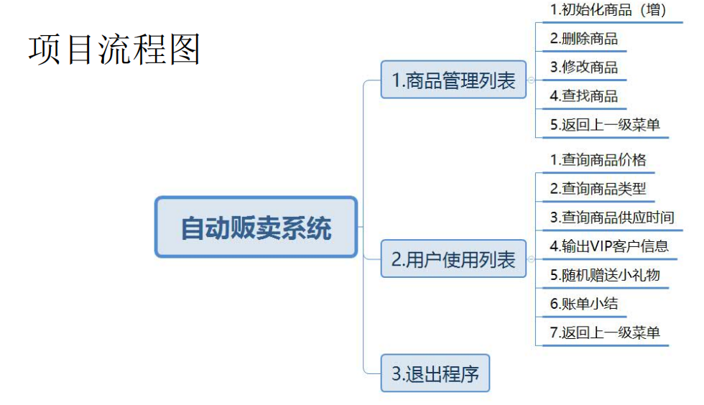
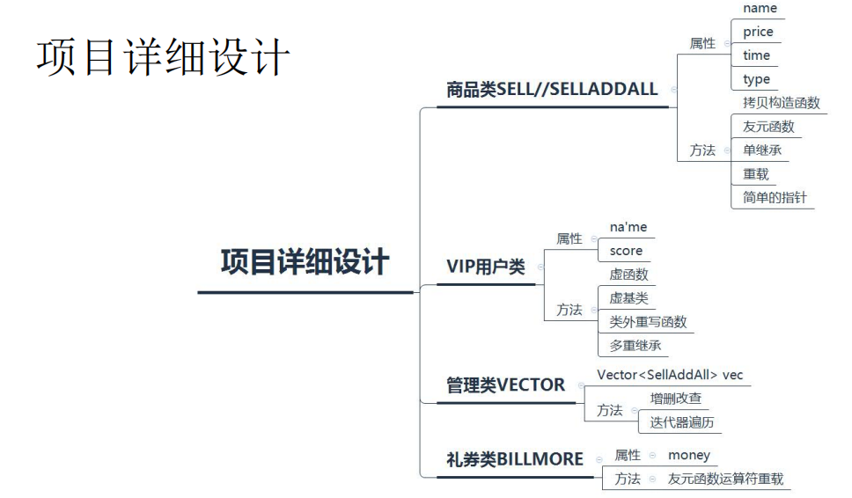

以下附程序代码：

/////////////////////////自动贩卖机//////////////////////////
#include<iostream>
using namespace std;
#include<string>
#include <cstring>
#include<math.h>
#include<vector>
//#include <afxsock.h>
//#include "stdafx.h"
using namespace std;
////////////////////////////继承/////////////////////////////
//【基类】
class Sell
{
public:
char* name;
int price;

Sell();//缺省构造函数
Sell(char*, int);//构造函数
Sell(const Sell& p);//拷贝构造函数
friend void printSell(Sell sell);//友元函数
~Sell()//析构函数 释放函数变量
{
cout << "正在初始化" << endl;
}
virtual void show();//虚函数
};
void Sell::show()//定义在类外的构造函数
{
cout << name << price << endl;
};
Sell::Sell()
{
this->name = "xxx";
this->price = 0;
};

Sell::Sell(char* name, int price) : name(name), price(price) {};//构造函数初始化变量

//Sell::Sell(char* name, int price)//初始化变量
//{
// name = name;
// price = price;
//};

Sell::Sell(const Sell& p)//拷贝构造函数（用Sell初始化Sell)
{
this->name = p.name;
this->price = p.price;
// cout<<"测试拷贝构造函数"<<endl;
};

//派生类
class SellAddAll : public Sell
{
public:
char* type;
char* time;

SellAddAll();
SellAddAll(char*, int, char*, char*);//重载
void display();
};
SellAddAll::SellAddAll()
{

this->time = "全天供应";
this->type = "yyy";

}
SellAddAll::SellAddAll(char* name, int price, char* time, char* type) : Sell(name, price)
{
this->time = time;
this->type = type;
}
void SellAddAll::display()
{
cout << "商品名称是:" << name << ",价格是:" << price << "，供应时间是" << time << "，商品类型是:" << type << endl;
}

static vector<SellAddAll> vec;//容器类定义，调用SellAddAll类的对象作为DeleteSell、ModifySell、QuerySell类的成员

/////////////////////////////////删除某一商品
class DeleteSell
{
public:
void Delete()
{
for (int i = 0; i < vec.size(); i++)//返回vec的元素
{
cout << (i + 1) << ":";
cout << vec[i].name << vec[i].price << endl;//调用name，price成员
}
cout << "请选择需要删除的商品编号:" << endl;
int x;
cin >> x;
vec.erase(vec.begin() + (x - 1));//删除字符
cout << "删除成功:" << endl;
}

};
//////////////////////////////////////////修改某一商品
class ModifySell
{
public:
void Modify()
{
for (int i = 0; i < vec.size(); i++)
{
cout << (i + 1) << ":";
cout << vec[i].name << vec[i].price << endl;
}

cout << "请选择需要修改的商品编号:" << endl;

}
};
//////////////////////////////////////////查询所有商品
class QuerySell
{
public:
void querysell()
{
cout << "当前商品信息为：" << endl;
/* for (auto it = vec.begin(); it != vec.end(); ++it)//此处测试集合（未实现）
{
cout << (*it).name << (*it).price << " ";
}*/
for (int i = 0; i < vec.size(); i++)
{
cout << "商品名称：" << vec[i].name << "商品价格：" << vec[i].price <<
"供应时间：" << vec[i].time << "商品种类：" << vec[i].type << endl;
}
cout << endl;
}
};
////////////////////////查询商品价格////////////////
class QueryPrice
{
//private:
// int pricenum ;
public:
void queryprice()
{
for (int i = 0; i < vec.size(); i++)
{
cout << (i + 1) << ":";
cout << vec[i].name << ":";
cout << vec[i].price << endl;
}

cout << "请选择需要查询价格的商品编号：";
int pricenum;
cin >> pricenum;
cout << "价格为:" << vec[pricenum - 1].price << endl;
}
};
//////////////////////查询商品种类///////////////
class QueryType
{
private:
int x;

public:
void querytype()
{
for (int i = 0; i < vec.size(); i++)
{
cout << (i + 1) << ":";
cout << vec[i].name << ":";
cout << vec[i].type << endl;
}
int typex;
cin >> typex;
cout << vec[typex - 1].type << endl;//type
// cout << "输出成功" << endl;
}
void show()
{
cout << "请选择需要查询的商品编号:" << endl;
}
};
//////////////////////////////////////查询商品供应时间
class SupplyTime
{
public:
void supplytime()
{
for (int i = 0; i < vec.size(); i++)
{
cout << (i + 1) << ":";
cout << vec[i].name << ":";
cout << vec[i].time << endl;
}
void show();
int typex;
cin >> typex;
cout << vec[typex - 1].time << endl;
cout << "输出成功" << endl;
}
void show()
{
cout << "请选择需要查询的商品编号:" << endl;
}
};
///////////////////////////账单小结/////////////////
class Bill
{
private:
int price[10];
int number[10];
public:
int x, y;
Bill() {};
void show()
{
int billkk = 1;
int moneysum = 0;
int sumnum = 0;
while (billkk == 1)
{
cout << "请选择商品:" << endl;
for (int i = 0; i < vec.size(); i++)
{
cout << i + 1 << ": ";
cout << vec[i].name << " " << vec[i].price << endl;
}
int billx;
cin >> billx;

price[sumnum] = vec[billx - 1].price;

cout << "请选择商品数量:" << endl;
int billy;
cin >> billy;
number[sumnum] = billy;
for (int j = 0; j <= sumnum; j++)
{
moneysum += price[j] * number[j];
}
cout << "当前总金额为:" << moneysum << endl;
cout << "是否选择继续添加商品（y继续，n结束）" << endl;
char yn;
cin >> yn;
if (yn == 'y')
{
}
else
{
billkk = 0;
};

};

};
};

class BillMore//随机促销礼券
{
public:
int money1;
int money2;
// money1 = money2 =0;
BillMore(void)
{
money1 = money2 = 0;
cout << "总金额为:" << money1 + money2 << endl;
};
BillMore(int a)
{
money1 = vec[rand() % a].price;
money2 = 0;
cout << "总金额为:" << money1 + money2 << endl;
}
BillMore(int a, int b)
{
money1 = vec[rand() % a].price;
money2 = vec[rand() % b].price;
cout << "总金额为:" << money1 + money2 << endl;
};
~BillMore() {};
friend BillMore operator+(const BillMore& px, const BillMore& py);//【友元函数重载运算符】
void print(void);
//cout<<"总金额为:"<<money1+money2<<endl; //（测试）
};
void BillMore::print()
{
cout << "恭喜您获得总金额为:" << money1 + money2 << "的抵扣券" << endl;
};

BillMore operator+(const BillMore& px, const BillMore& py)//【友元函数重载运算符】
{
return BillMore(px.money1 + py.money1, px.money2 + py.money2);
};

////////////////////////////多继承
class Vip1
{
protected:
char Name[100];
public:
Vip1(char* n)
{
strcpy_s(Name, n);
}
virtual void show();//虚函数
};

class Vip2 :virtual public Vip1
{
private:
char university_name[20];
public:
Vip2(char* n, char* un_n) :Vip1(n)
{
strcpy_s(university_name, un_n);
}
virtual void show();
};

class Vip3 :virtual public Vip1 //虚基类
{
private:
int course1;
public:
Vip3(char* n, char* a, int c1) :Vip1(n)
{
course1 = c1;
}
virtual void show();
};

class All : public Vip2, public Vip3//派生类【多继承】
{
private:
int u;
public:
All(char* n, char* a, char* un_n, int c1, int uu) :Vip1(n), Vip2(n, un_n), Vip3(n, a, c1)
{
u = uu;
};
void show();
};
void All::show()
{
Vip3::show();
}

void Vip1::show()
{
cout << endl;
cout << "姓名：" << Name << endl;
}
void Vip2::show()
{
Vip1::show();
cout << "大学名称：" << university_name << endl;
}
void Vip3::show()
{
Vip1::show();
cout << "会员积分：" << course1 << endl;
///////////////////主菜单///////////////
class MShow
{
public:
void show()
{
cout << "请选择:" << endl;
cout << "1.管理员列表" << endl;
cout << "2.客户购买列表" << endl;
cout << "3.程序结束" << endl;
}
};
//////////////管理员界面菜单/////////////////
class ListShowOne
{
public:
void show()
{
cout << "请选择：" << endl;
cout << "1.初始化商品信息" << endl;
cout << "2.删除商品信息" << endl;
cout << "3.修改商品信息" << endl;
cout << "4.查询商品所有信息" << endl;
cout << "5.返回上级菜单" << endl;
}
};
//////////////////客户端菜单/////////////////
class ListShowTwo
{
public:
void show()
{
cout << "请选择:" << endl;
cout << "1.商品价格查询" << endl;
cout << "2.商品类型查询" << endl;
cout << "3.商品供应时间查询" << endl;
cout << "4.输出VIP信息" << endl;
cout << "5.随机赠送礼品" << endl;
cout << "6.账单小结" << endl;
cout << "7.返回上级菜单" << endl;
}
};
int main() {
///////商品售卖列表///////////
SellAddAll A("可乐", 3, "全天供应", "饮料");//定义类的多个对象
SellAddAll B("炒饭", 5, "早上八点", "主食");
SellAddAll C("瓜子", 7, "全天供应", "零食");
SellAddAll D("泡面", 10, "晚上八点", "宵夜");
SellAddAll E("自热小火锅", 30, "晚上八点", "宵夜");

/////////VIP用户信息////////////////
int q, w;
q = 2; w = 3;
Vip1* p, A2("曾瑶瑶");
All D2("曾瑶瑶", "China", "School", 95, 10);
p = &D2;

///////////操作动作//////////////
cout << "欢迎来到自动贩卖机" << endl;
while (true) {
MShow m;
m.show();
int mainx;
cin >> mainx;

//////// 管理员列表/////////
if (mainx == 1)
{
ListShowOne one;
one.show();
int listtwochoice;
cin >> listtwochoice;
switch (listtwochoice)
{
case 1:
vec.push_back(A);//容器类对象插入A内容
vec.push_back(B);
vec.push_back(C);
vec.push_back(D);
cout << "增加成功" << endl;
break;
case 2:
while (true) {
DeleteSell d;
d.Delete();
cout << "是否继续（1/0）" << endl;
int kk2;
cin >> kk2;
if (kk2 == 0) {
break;
};
}
break;
case 3:
ModifySell m;
m.Modify();
int x;
cin >> x;
vec[x - 1] = E;
cout << "修改成功" << endl;
break;
case 4:
QuerySell q;
q.querysell();
break;
case 5:
break;
};
}
////////////用户购买列表////////////
else if (mainx == 2)
{
ListShowTwo two;
two.show();
int casetwo;
cin >> casetwo;
switch (casetwo)
{
case 1:while (true)
{
QueryPrice qp;
qp.queryprice();
cout << "是否继续（1/0）" << endl;
int qq1;
cin >> qq1;
if (qq1 == 0) {
break;
};
}
break;
case 2:
while (true) {
QueryType qt;

qt.show();
qt.querytype();
cout << "是否继续（1/0）" << endl;
int qq2;
cin >> qq2;
if (qq2 == 0) {
break;
};
}
break;
case 3:while (true) {
SupplyTime st;
st.show();
st.supplytime();
cout << "是否继续（1/0）" << endl;
int qq3;
cin >> qq3;
if (qq3 == 0) {
break;
};
}
break;
case 4:
cout << "输出唯一VIP会员信息：" << endl;
p->show();
break;
case 5:
{
BillMore billmore(3);
billmore.print();
break;
}
case 6:
Bill bill;
bill.show();
break;
}
}
/////////程序结束/////////////
else if (mainx == 3)
{
cout << "欢迎下次使用" << endl;
break;
}
}
}

完整代码：
/////////////////////////自动贩卖机//////////////////////////
#include<iostream>
using namespace std;
#include<string>
#include <cstring>
#include<math.h>
#include<vector>
//#include <afxsock.h>
//#include "stdafx.h"
using namespace std;
////////////////////////////继承/////////////////////////////
//【基类】
class Sell
{
public:
char* name;
int price;

Sell();//缺省构造函数
Sell(char*, int);//构造函数
Sell(const Sell& p);//拷贝构造函数
friend void printSell(Sell sell);//友元函数
~Sell()//析构函数 释放函数变量
{
cout << "正在初始化" << endl;
}
virtual void show();//虚函数
};
void Sell::show()//定义在类外的构造函数
{
cout << name << price << endl;
};
Sell::Sell()
{
this->name = "xxx";
this->price = 0;
};

Sell::Sell(char* name, int price) : name(name), price(price) {};//构造函数初始化变量

//Sell::Sell(char* name, int price)//初始化变量
//{
// name = name;
// price = price;
//};

Sell::Sell(const Sell& p)//拷贝构造函数（用Sell初始化Sell)
{
this->name = p.name;
this->price = p.price;
// cout<<"测试拷贝构造函数"<<endl;
};

//派生类
class SellAddAll : public Sell
{
public:
char* type;
char* time;

SellAddAll();
SellAddAll(char*, int, char*, char*);//重载
void display();
};
SellAddAll::SellAddAll()
{

this->time = "全天供应";
this->type = "yyy";

}
SellAddAll::SellAddAll(char* name, int price, char* time, char* type) : Sell(name, price)
{
this->time = time;
this->type = type;
}
void SellAddAll::display()
{
cout << "商品名称是:" << name << ",价格是:" << price << "，供应时间是" << time << "，商品类型是:" << type << endl;
}

static vector<SellAddAll> vec;//容器类定义，调用SellAddAll类的对象作为DeleteSell、ModifySell、QuerySell类的成员

/////////////////////////////////删除某一商品
class DeleteSell
{
public:
void Delete()
{
for (int i = 0; i < vec.size(); i++)//返回vec的元素
{
cout << (i + 1) << ":";
cout << vec[i].name << vec[i].price << endl;//调用name，price成员
}
cout << "请选择需要删除的商品编号:" << endl;
int x;
cin >> x;
vec.erase(vec.begin() + (x - 1));//删除字符
cout << "删除成功:" << endl;
}

};
//////////////////////////////////////////修改某一商品
class ModifySell
{
public:
void Modify()
{
for (int i = 0; i < vec.size(); i++)
{
cout << (i + 1) << ":";
cout << vec[i].name << vec[i].price << endl;
}

cout << "请选择需要修改的商品编号:" << endl;

}
};
//////////////////////////////////////////查询所有商品
class QuerySell
{
public:
void querysell()
{
cout << "当前商品信息为：" << endl;
/* for (auto it = vec.begin(); it != vec.end(); ++it)//此处测试集合（未实现）
{
cout << (*it).name << (*it).price << " ";
}*/
for (int i = 0; i < vec.size(); i++)
{
cout << "商品名称：" << vec[i].name << "商品价格：" << vec[i].price <<
"供应时间：" << vec[i].time << "商品种类：" << vec[i].type << endl;
}
cout << endl;
}
};
////////////////////////查询商品价格////////////////
class QueryPrice
{
//private:
// int pricenum ;
public:
void queryprice()
{
for (int i = 0; i < vec.size(); i++)
{
cout << (i + 1) << ":";
cout << vec[i].name << ":";
cout << vec[i].price << endl;
}

cout << "请选择需要查询价格的商品编号：";
int pricenum;
cin >> pricenum;
cout << "价格为:" << vec[pricenum - 1].price << endl;
}
};
//////////////////////查询商品种类///////////////
class QueryType
{
private:
int x;

public:
void querytype()
{
for (int i = 0; i < vec.size(); i++)
{
cout << (i + 1) << ":";
cout << vec[i].name << ":";
cout << vec[i].type << endl;
}
int typex;
cin >> typex;
cout << vec[typex - 1].type << endl;//type
// cout << "输出成功" << endl;
}
void show()
{
cout << "请选择需要查询的商品编号:" << endl;
}
};
//////////////////////////////////////查询商品供应时间
class SupplyTime
{
public:
void supplytime()
{
for (int i = 0; i < vec.size(); i++)
{
cout << (i + 1) << ":";
cout << vec[i].name << ":";
cout << vec[i].time << endl;
}
void show();
int typex;
cin >> typex;
cout << vec[typex - 1].time << endl;
cout << "输出成功" << endl;
}
void show()
{
cout << "请选择需要查询的商品编号:" << endl;
}
};
///////////////////////////账单小结/////////////////
class Bill
{
private:
int price[10];
int number[10];
public:
int x, y;
Bill() {};
void show()
{
int billkk = 1;
int moneysum = 0;
int sumnum = 0;
while (billkk == 1)
{
cout << "请选择商品:" << endl;
for (int i = 0; i < vec.size(); i++)
{
cout << i + 1 << ": ";
cout << vec[i].name << " " << vec[i].price << endl;
}
int billx;
cin >> billx;

price[sumnum] = vec[billx - 1].price;

cout << "请选择商品数量:" << endl;
int billy;
cin >> billy;
number[sumnum] = billy;
for (int j = 0; j <= sumnum; j++)
{
moneysum += price[j] * number[j];
}
cout << "当前总金额为:" << moneysum << endl;
cout << "是否选择继续添加商品（y继续，n结束）" << endl;
char yn;
cin >> yn;
if (yn == 'y')
{
}
else
{
billkk = 0;
};

};

};
};
class BillMore//随机促销礼券
{
public:
int money1;
int money2;
// money1 = money2 =0;
BillMore(void)
{
money1 = money2 = 0;
cout << "总金额为:" << money1 + money2 << endl;
};
BillMore(int a)
{
money1 = vec[rand() % a].price;
money2 = 0;
cout << "总金额为:" << money1 + money2 << endl;
}
BillMore(int a, int b)
{
money1 = vec[rand() % a].price;
money2 = vec[rand() % b].price;
cout << "总金额为:" << money1 + money2 << endl;
};
~BillMore() {};
friend BillMore operator+(const BillMore& px, const BillMore& py);//【友元函数重载运算符】
void print(void);
//cout<<"总金额为:"<<money1+money2<<endl; //（测试）
};
void BillMore::print()
{
cout << "恭喜您获得总金额为:" << money1 + money2 << "的抵扣券" << endl;
};

BillMore operator+(const BillMore& px, const BillMore& py)//【友元函数重载运算符】
{
return BillMore(px.money1 + py.money1, px.money2 + py.money2);
};

////////////////////////////多继承
class Vip1
{
protected:
char Name[100];
public:
Vip1(char* n)
{
strcpy_s(Name, n);
}
virtual void show();//虚函数
};

class Vip2 :virtual public Vip1
{
private:
char university_name[20];
public:
Vip2(char* n, char* un_n) :Vip1(n)
{
strcpy_s(university_name, un_n);
}
virtual void show();
};

class Vip3 :virtual public Vip1 //虚基类
{
private:
int course1;
public:
Vip3(char* n, char* a, int c1) :Vip1(n)
{
course1 = c1;
}
virtual void show();
};

class All : public Vip2, public Vip3//派生类【多继承】
{
private:
int u;
public:
All(char* n, char* a, char* un_n, int c1, int uu) :Vip1(n), Vip2(n, un_n), Vip3(n, a, c1)
{
u = uu;
};
void show();
};
void All::show()
{
Vip3::show();
}

void Vip1::show()
{
cout << endl;
cout << "姓名：" << Name << endl;
}
void Vip2::show()
{
Vip1::show();
cout << "大学名称：" << university_name << endl;
}
void Vip3::show()
{
Vip1::show();
cout << "会员积分：" << course1 << endl;
}
///////////////////主菜单///////////////
class MShow
{
public:
void show()
{
cout << "请选择:" << endl;
cout << "1.管理员列表" << endl;
cout << "2.客户购买列表" << endl;
cout << "3.程序结束" << endl;
}
};
//////////////管理员界面菜单/////////////////
class ListShowOne
{
public:
void show()
{
cout << "请选择：" << endl;
cout << "1.初始化商品信息" << endl;
cout << "2.删除商品信息" << endl;
cout << "3.修改商品信息" << endl;
cout << "4.查询商品所有信息" << endl;
cout << "5.返回上级菜单" << endl;
}
};
//////////////////客户端菜单/////////////////
class ListShowTwo
{
public:
void show()
{
cout << "请选择:" << endl;
cout << "1.商品价格查询" << endl;
cout << "2.商品类型查询" << endl;
cout << "3.商品供应时间查询" << endl;
cout << "4.输出VIP信息" << endl;
cout << "5.随机赠送礼品" << endl;
cout << "6.账单小结" << endl;
cout << "7.返回上级菜单" << endl;
}
};
int main() {
///////商品售卖列表///////////
SellAddAll A("可乐", 3, "全天供应", "饮料");//定义类的多个对象
SellAddAll B("炒饭", 5, "早上八点", "主食");
SellAddAll C("瓜子", 7, "全天供应", "零食");
SellAddAll D("泡面", 10, "晚上八点", "宵夜");
SellAddAll E("自热小火锅", 30, "晚上八点", "宵夜");

/////////VIP用户信息////////////////
int q, w;
q = 2; w = 3;
Vip1* p, A2("曾瑶瑶");
All D2("曾瑶瑶", "China", "School", 95, 10);
p = &D2;

///////////操作动作//////////////
cout << "欢迎来到自动贩卖机" << endl;
while (true) {
MShow m;
m.show();
int mainx;
cin >> mainx;

//////// 管理员列表/////////
if (mainx == 1)
{
ListShowOne one;
one.show();
int listtwochoice;
cin >> listtwochoice;
switch (listtwochoice)
{
case 1:
vec.push_back(A);//容器类对象插入A内容
vec.push_back(B);
vec.push_back(C);
vec.push_back(D);
cout << "增加成功" << endl;
break;
case 2:
while (true) {
DeleteSell d;
d.Delete();
cout << "是否继续（1/0）" << endl;
int kk2;
cin >> kk2;
if (kk2 == 0) {
break;
};
}
break;
case 3:
ModifySell m;
m.Modify();
int x;
cin >> x;
vec[x - 1] = E;
cout << "修改成功" << endl;
break;
case 4:
QuerySell q;
q.querysell();
break;
case 5:
break;
};
}
////////////用户购买列表////////////
else if (mainx == 2)
{
ListShowTwo two;
two.show();
int casetwo;
cin >> casetwo;
switch (casetwo)
{
case 1:while (true)
{
QueryPrice qp;
qp.queryprice();
cout << "是否继续（1/0）" << endl;
int qq1;
cin >> qq1;
if (qq1 == 0) {
break;
};
}
break;
case 2:
while (true) {
QueryType qt;

qt.show();
qt.querytype();
cout << "是否继续（1/0）" << endl;
int qq2;
cin >> qq2;
if (qq2 == 0) {
break;
};
}
break;
case 3:while (true) {
SupplyTime st;
st.show();
st.supplytime();
cout << "是否继续（1/0）" << endl;
int qq3;
cin >> qq3;
if (qq3 == 0) {
break;
};
}
break;
case 4:
cout << "输出唯一VIP会员信息：" << endl;
p->show();
break;
case 5:
{
BillMore billmore(3);
billmore.print();
break;
}
case 6:
Bill bill;
bill.show();
break;
}
}
/////////程序结束/////////////
else if (mainx == 3)
{
cout << "欢迎下次使用" << endl;
break;
}
}
}

